This section of the guidance has been replaced (from December 2016), and is here just for your information. DeafATW has been told that the AtW guidance available on the web will be updated to include this soon.

Types of Support Worker

British Sign Language (BSL) Interpreter

524. BSL Interpreters are specialist trained. They interpret English into BSL for deaf people or those with hearing problems.

525. There are different levels of qualification that interpreters achieve. You should make sure that a customer requiring this support understands the type of work situation that each skill level of interpreter can support. The customer must be able to make an informed decision about the level of BSL skill they need.

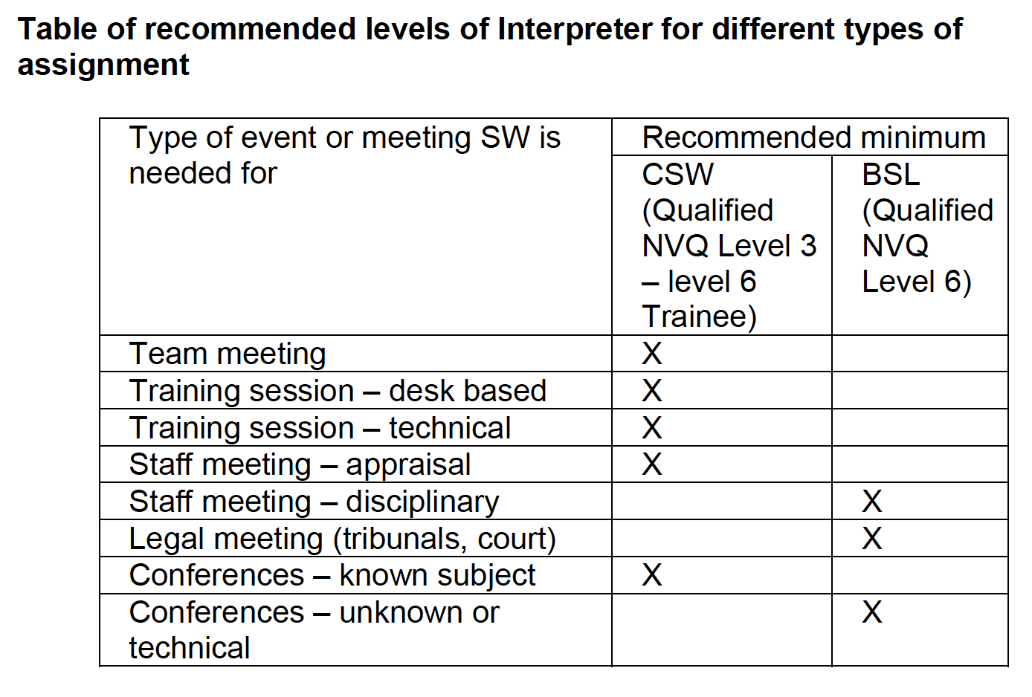

Level 3 and Level 6 (Trainee) Communication Support Worker (CSW)

526. Communication Support Workers are qualified at NVQ BSL level 3 minimum, or level 6 Trainee, accredited by Signature

527. CSW are able to practice in most employment related environments (for example social workers, teachers of the Deaf, communicators, workers within Deaf organisations, schools, etc.).

Level 6

528. Interpreters are qualified at NVQ BSL Level 6, accredited by Signature & will have several years’ experience of regular BSL and are fluent in English & BSL.

529. BSL Level 6 interpreters are competent to practice in any employment related environment.

General Considerations for all Interpreters

530. It is advisable that interpreters should not be expected to work for more than two hours without a break. If an event needs continuous interpretation for more than two hours two interpreters may be needed.

531. The event/environment
• is this linked to the customer’s actual job?
• has the employer/event organiser made all reasonable adjustments?
• is the setting informal or formal?
• are there structured breaks in place?
• will there be ‘break out’ or syndicate exercises?

532. It is reasonable to expect breaks in any meeting/work activity, explore this with the customer.

533. If a second interpreter is needed you must talk about the possibility of the employer providing as part of a reasonable adjustment.

534. There are a number of issues to consider before agreeing what interpreter support is needed.

535. The participants
• is it a straightforward one-to-one meeting?
• is there a large audience?
• are there several people going who require a BSL Interpreter?

536. The content
• is the topic straightforward?
• how important is the content?
• will there be a rapid change over of speakers that makes interpreting more difficult?
• what are the implications for the customer or others if there is a misinterpretation?

