Guidance about what to take into account when agreeing what skills / experience / qualifications etc. are required from interpreters.
Additional support worker costs / Cancellation fees
Types of Support Worker
- British Sign Language (BSL) Interpreter
- Carer
- Counsellor
- Driver
- Job-Aide
- Job Coach
- Lip Speaker
- Note Taker
- Palantypist
- Personal Reader
- Travel Buddy
- British Sign Language (BSL) Interpreter

402. BSL Interpreters are people who have undertaken specialist training to be able to interpret English into BSL for Deaf people or those with hearing difficulties.

403. There are varying levels of qualification that Interpreters may have achieved. You should ensure that customers, who require BSL interpreter support, understand the types of work situation that each skill level of interpreter can support.

The customer must be able to make an informed decision about the level of BSL skill they require.

Table of recommended levels of Interpreter for different types of assignment

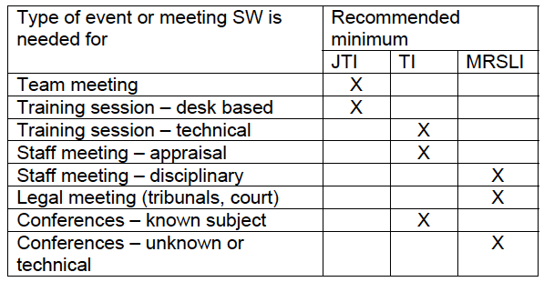

A Junior Trainee Interpreter (JTI) [This information is out of date]

404. Qualified at NVQ level 3, and registered with SIGNATURE, the national registration body.

405. This level of interpreter qualification does not exist in Scotland, the next level (TI) will be the minimum for supporting Scottish customer’s team meetings and desk based training.

406. JTIs are competent to practice in some employment related environments, but should work under supervision.
A Trainee Interpreter (TI)

A Trainee Interpreter (TI)

407. Qualified at NVQ level 4, has completed a recognised interpreter qualification and is working towards becoming a fully qualified interpreter. Tis will have several months work experience and be registered with SIGNATURE, the national registration body.

408. TIs are competent to practice in most employment related environments. A Member of the Register of Sign Language Interpreters (MRSL)

A Member of the Register of Sign Language Interpreters (MRSL)

409. Qualified at NVQ Level 4 or has a recognised postgraduate diploma.

410. MRSLIs have several years experience of regular usage of BSL and are registered with SIGNATURE, the national registration body. They have complete fluency in English and BSL.

411. MRSLIs are competent to practice in any employment related environment.

General Considerations for all Interpreters

412. Interpreters cannot be expected to work for more than two hours without a break, if an event will require continuous interpretation for more than two hours two interpreters will be required.

413. There are a number of issues you will need to consider before agreeing what interpreter support needs to be put in place:

414. The event/environment
• Is this linked to the customer’s actual job?
• Have the employer/event organiser made all reasonable adjustments?
• Is the setting informal or formal?
• Are there structured breaks in place?
• Will there be ‘break out’ or syndicate exercises?

415. The participants
• Is it a straightforward one-to-one meeting?
• Is there a large audience?
• Are there several people attending who will require a BSL Interpreter?

416. The content
• Is the topic straightforward or will it require specialist knowledge?
• How important is the content?
• Will there be a rapid change over of speakers that could make interpreting more difficult?
• What are the implications for the customer or others if there is a misinterpretation?

